Reflections from the Field
February 13, 2025

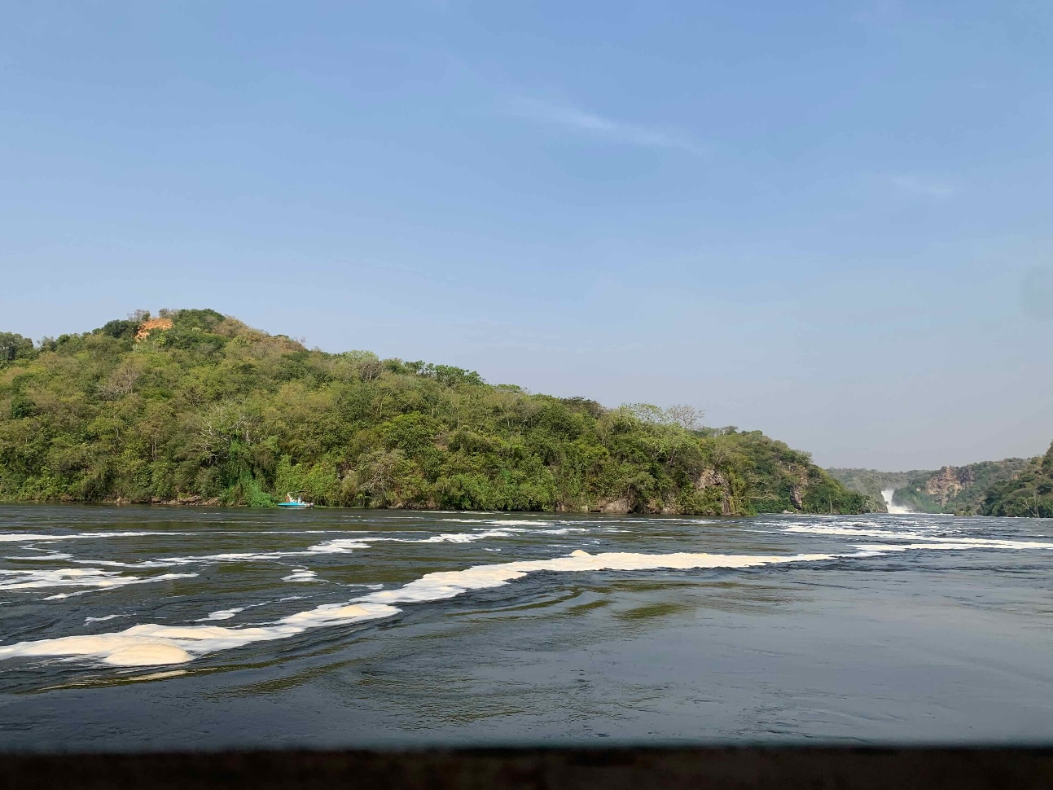

Greetings from sunny Uganda where the Walugembe family has been caught up with celebrations even in the midst of trials and hardships. As we all know, this is the stuff of life: the wins and the loses, the showing up for each other and the struggles we all face. Recently, I’ve had two friends mention something to the effect of: I don’t know how you do it! My friends, we are all going through it. We’re all facing trials and also celebrating the things that light us up. I pray you find more reasons to rejoice. I also commit to sticking by your side in the hard stuff. We’ve gotten caught up with life itself and it is a joy to finally sit down to update you again!

“Count it all joy, my brothers, when you meet trials of various kinds, for you know that the testing of your faith produces steadfastness. And let steadfastness have its full effect, that you may be perfect and complete, lacking in nothing.” James 1:2-4

December was a hot season for us and a busy one! It always is! Even as we dream of how to make it less crazy next year, we rejoice that God was in it and he gave us the strength to persist in ministry during that beautiful month where we celebrate the best gift of all: Jesus Christ! As you have done for 5 years before this, many of you helped us again this year as we reached out to the neediest of the needy in our immediate area with Christmas Blessing Baskets! This year we set a goal of 25 and through your generosity reached 40 baskets total. That means 40 families received a bountiful basket along with a home visit, encouraging message, and prayer. It was an intense season because while we have an idea of who we would like to bless, we are also open to the prompting of the Spirit. This year took us, once again, into places we’d not yet visited. Ministering to the hungry is not for the faint of heart. It was a huge blessing but also challenged us emotionally and physically.
On one such home visit we noticed a mud house tucked behind a field of sugar cane. As we rounded the corner I thought it looked like a new home we hadn’t seen before. Just as we had wondered who might live there, a man came out of a two-track nearby on a motorcycle. Turns out, it was his home. He must have been puzzled as we asked him to wait just a minute and take us back to his home. He led us back and parked his motorcycle under a flowering tree. Immediately, his wife with 5 children toddling behind her came to greet us. The home visit was a needed one. They needed help and were open and receptive to our message and the prayers we offered. This was one of the very few homes we actually went inside. I’m so glad we did, because there was precious little, solidifying our decision to stop there. The children all knelt to pray when that time came. The joy in the home was palpable. That’s what the love of Jesus does: it causes us to become vessels of his LIFE and HOPE and GOODWILL toward all. We thank God for sustaining us all to be able to reach out with a simple and timely gift.

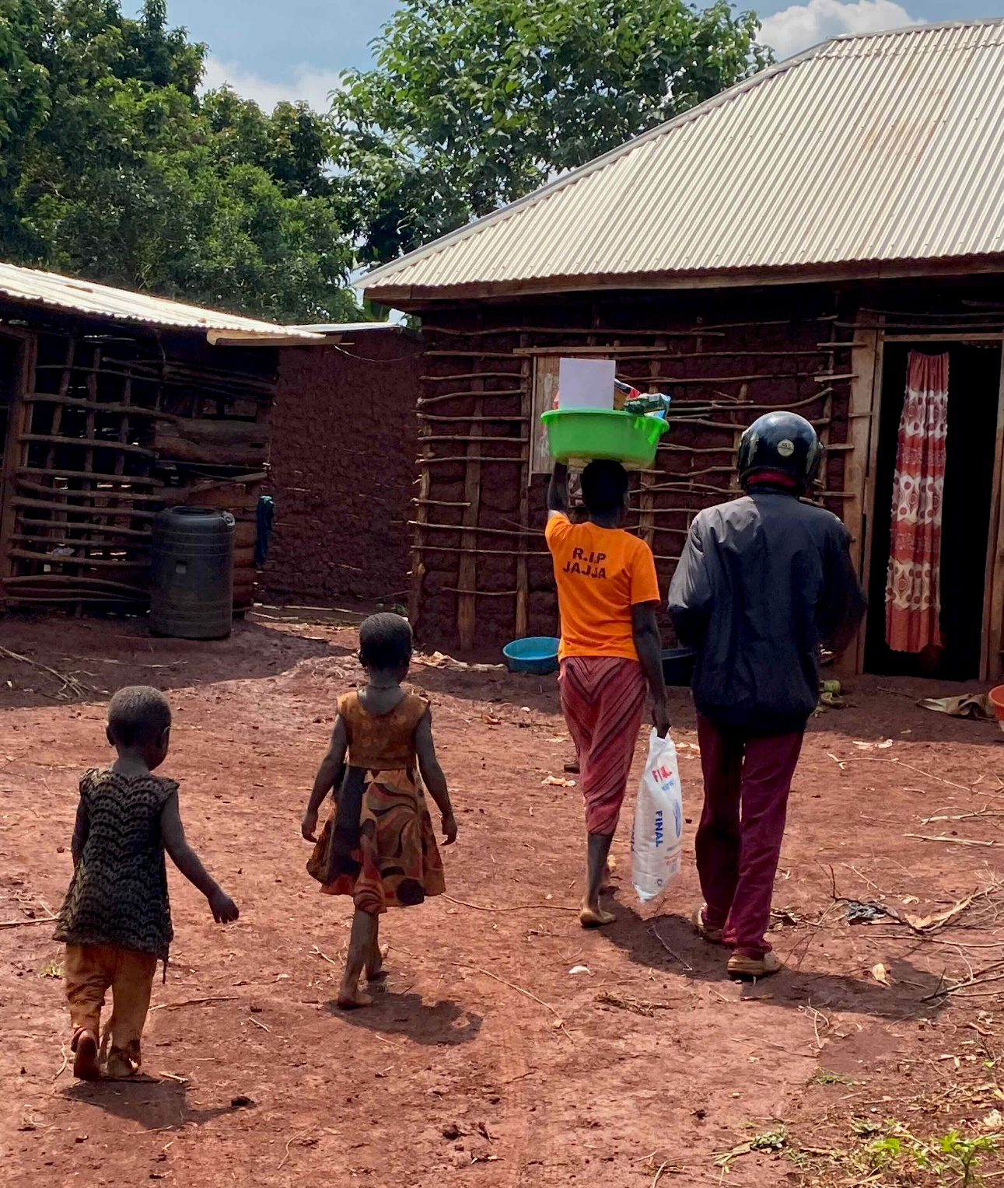

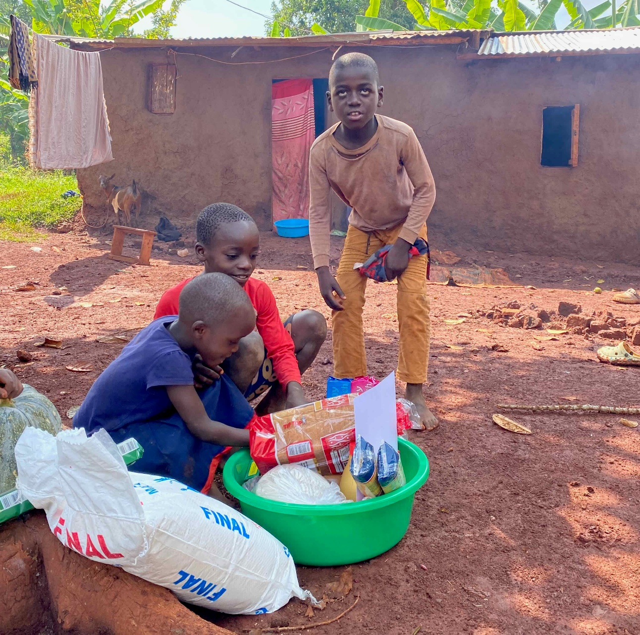

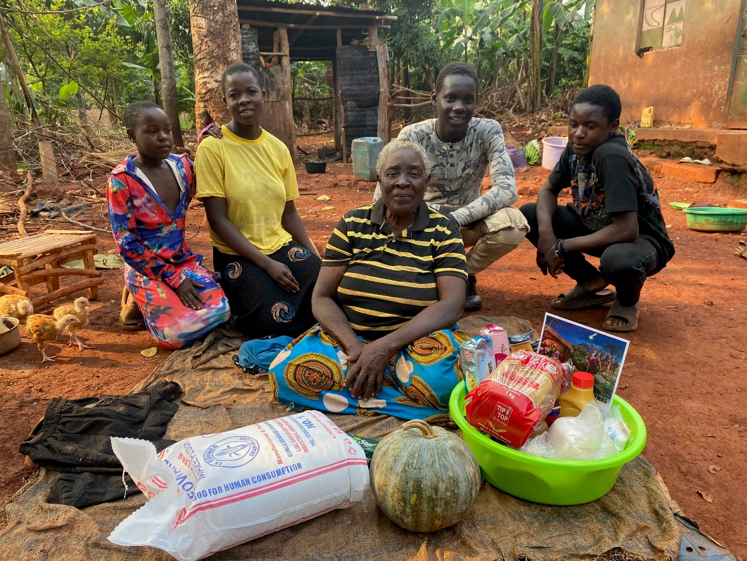

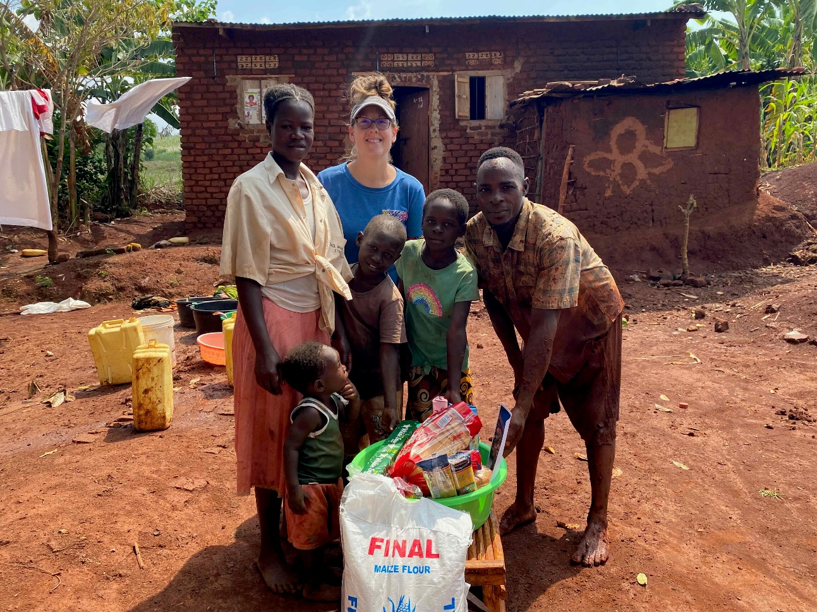

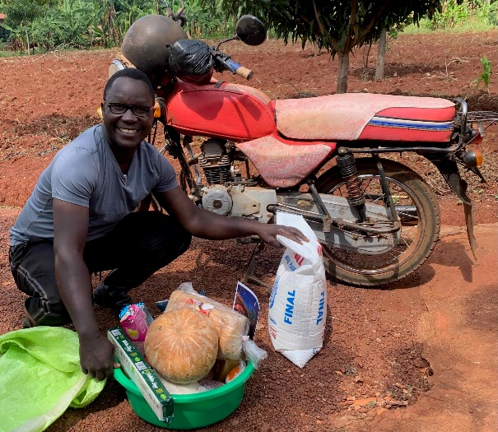
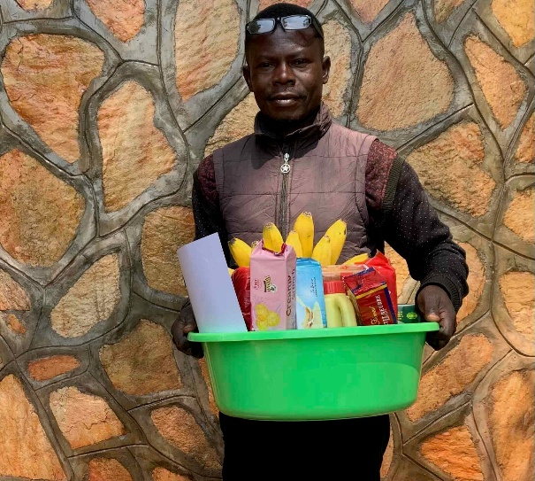

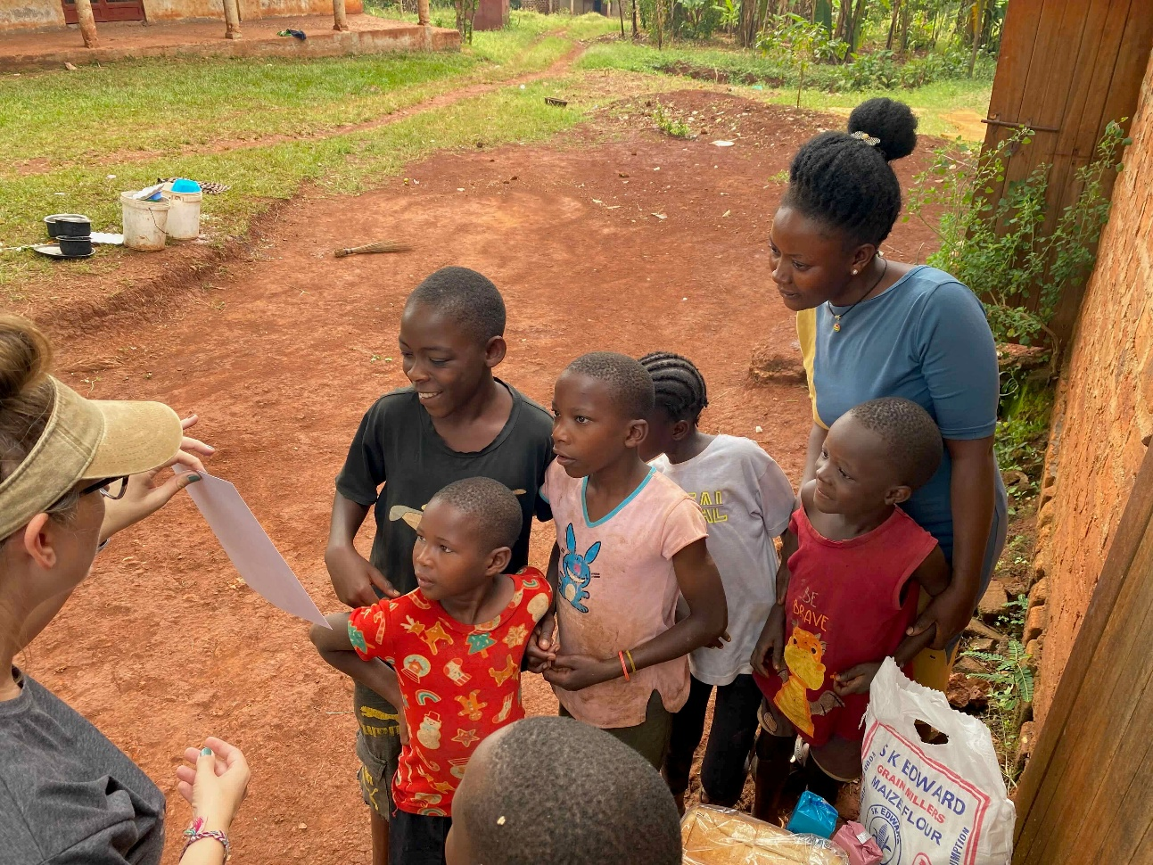

“Do not neglect to do good and to share what you have, for such sacrifices are pleasing to God.” Hebrews 13:16

Besides outreach in our village, we also got wrapped up in serving at our city church with our annual Christmas Cantata which reaches our city with the Christmas story in a creative production! All of us chipped in in one way or another and got busy serving and loving Jinja for Jesus! By the time Christmas rolled around, we realized we hadn’t had a single day at home for over 4 weeks straight. Christmas Day became our rest! How appropriate to rest in our Savior. We enjoyed being home and together for a few days! When January came, we celebrated Aiden’s 16th birthday with a quick trip to our favorite Ugandan game park where we tried to refresh and got to see hyenas for the first time in the wild. It was right back to school and ministry when we returned—back to business!

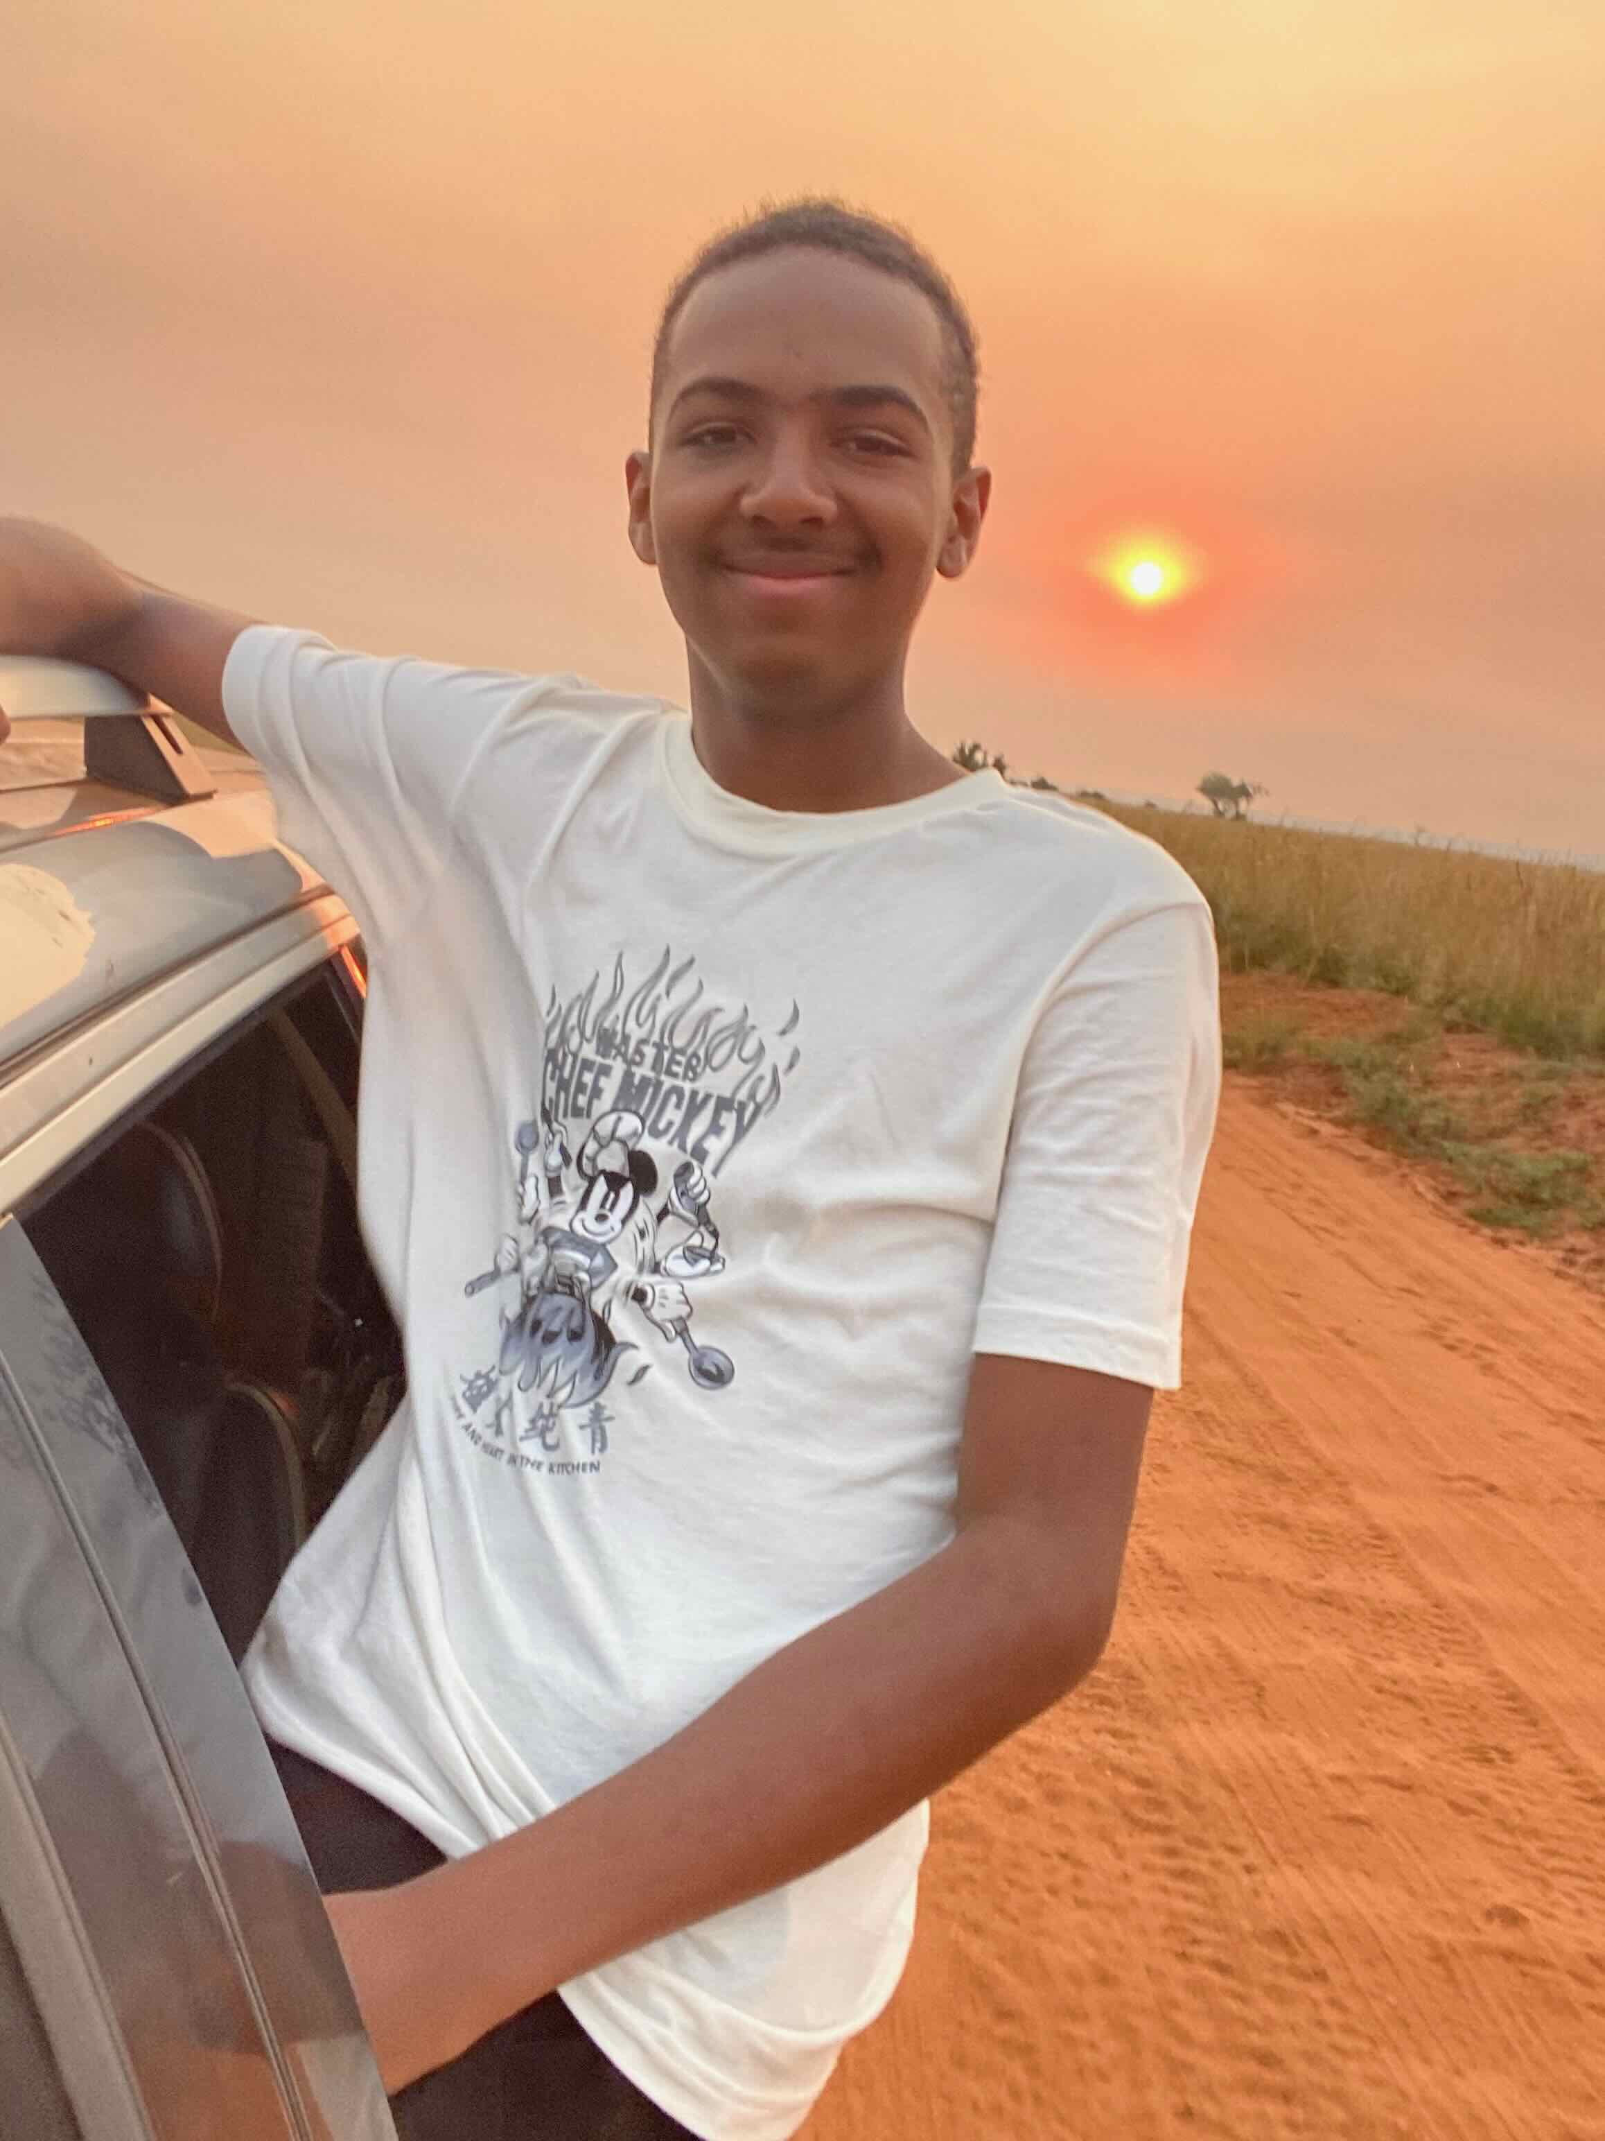

Eliana had an opportunity for a kids' program through our church in the city (about 20 minutes away in Jinja). So most of December and January we were dropping her off there and picking her up in the evening. The children of our church did a marvelous production called, “Born For This” highlighting Queen Esther’s story and our own calling and responsibility to it! It was beautifully done and such a gift to so many! Eliana was a dancer in a few of the songs and is really coming out of her shell and finding her talents! We celebrated her 11th birthday on the February 5th with her first ever birthday bash with friends. She’s really made some sweet friendships through our church! We thank God!

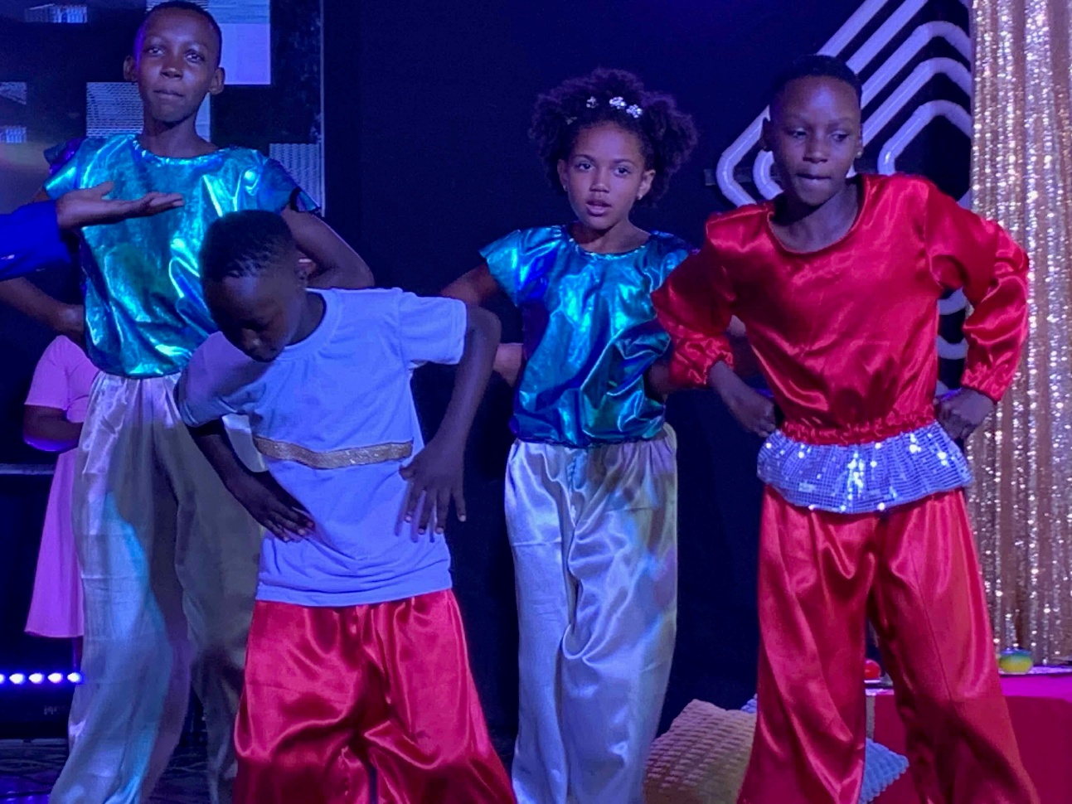

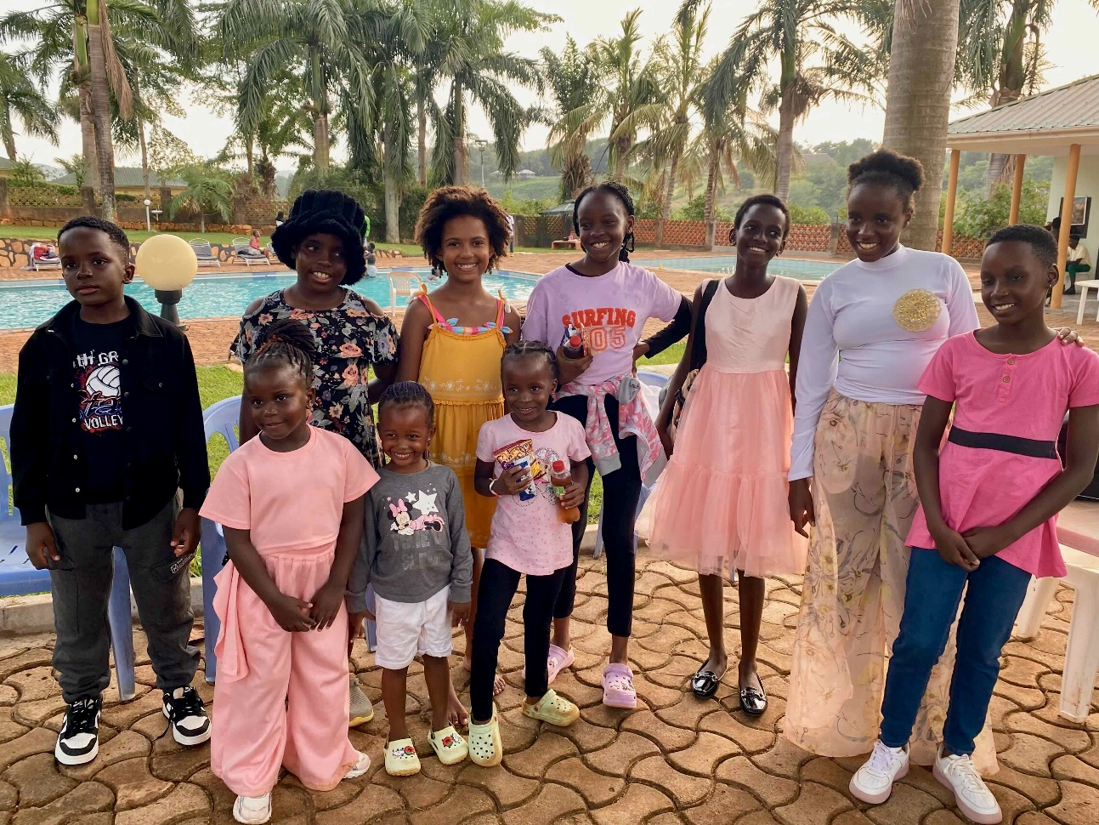

We were hit by extreme heat by about the time our Michigan friends were struck by extreme cold in January. We nearly ran out of water; neighbors even hired the fire brigade to bring in water to fill their tanks. Just when ours were drying up and we were getting ready to spend an exorbitant price for the gift of water, the sky cracked open for the first time in over 2 months and we all rejoiced at the filling of the tanks, not to mention the reduced temperatures. The early mornings with rain always remind us of autumn in Mackinaw or Carp Lake! It’s been a refresher! And by now, we are used to the hot, dry seasons and the life-giving rainy seasons.

“O God, you are my God; earnestly I seek you; my soul thirsts for you; my flesh faints for you; as in a dry and weary land where there is no water.” Psalm 63:1

Part of life is indeed standing with and for each other in all types of situations. We thank God that we’re plugged into our church community where the kids are thriving in serving, growing in God, and finding true friends. We thank God that though there have been horrible occurrences around us, we can be a part by supporting others in their worst moments. Just yesterday a young man who leads worship at church was attacked by thugs who left him for dead. Our church community raised up with support and care for him, covering a large medical bill as well. It’s a privilege and a great responsibility to stand alongside him. We also thank God for his provision of YOU! This body of like-minded believers has stood with us and empowered us to stand with many! We couldn’t do it without you!

Thank you for your support—prayers and financial. Thank you for reaching out from time to time, which is such an encouragement! January 15th began an election season in Uganda that was a bit tumultuous. Internet connection was cut off for several days, social media has been on and off ever since. Being disconnected is not good for us. It reminds me how in Christ we are to be united and of one spirit. Thank you, to all those who continue to be our support and for allowing us into your lives though we are far in distance. Thank you to those who have joined in our support team by choosing to partner with us on a regular basis AND to those who have increased their monthly support to keep us serving Jesus in Uganda. We appreciate and love you! We are still honored to serve and open to God’s leading us into further ministry in this expanding ministry we are part of.

“Behold, how good and pleasant it is when brothers dwell in unity!” Psalm 133:1

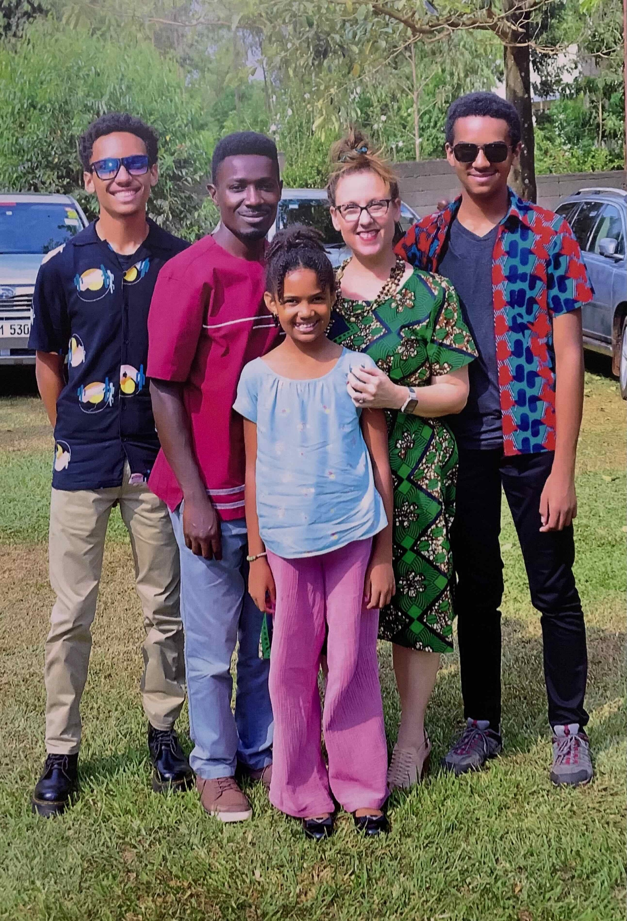

Much love to you from the Walugembe Family!
Peter and Kate (Levi, Aiden and Eliana) Walugembe

Link to Pioneers for Giving Options

Checks can be written to “Pioneers”
10123 William Carey Dr., Orlando, FL, 32832 for
Peter and Kate Walugembe
Acc. 111654

Click here to reply

www.northernlightsministries.org
Copyright © *2026* *Walugembe*

